GrandeOmega short guide

Table of contents

Types of exercises 2

Multiple choice questions 2

Forward assignment 2

Backward assignment 3

Dashboard 5

Exam 6

The website is <https://grandeomega.com>. Note that the best browser to use this website is *Google Chrome*; using other browsers is not recommended as you might encounter some issues.

When you open the website, you must click on **Login** and insert your credentials. All students have received credentials via the email of the school. If not, please contact immediately [abbam@hr.nl](mailto:abbam@hr.nl).

After logging in, press on **Courses** and then select the course (Development 1 for example). After selecting it, you will see the list of didactic units available, like practicums and exams.

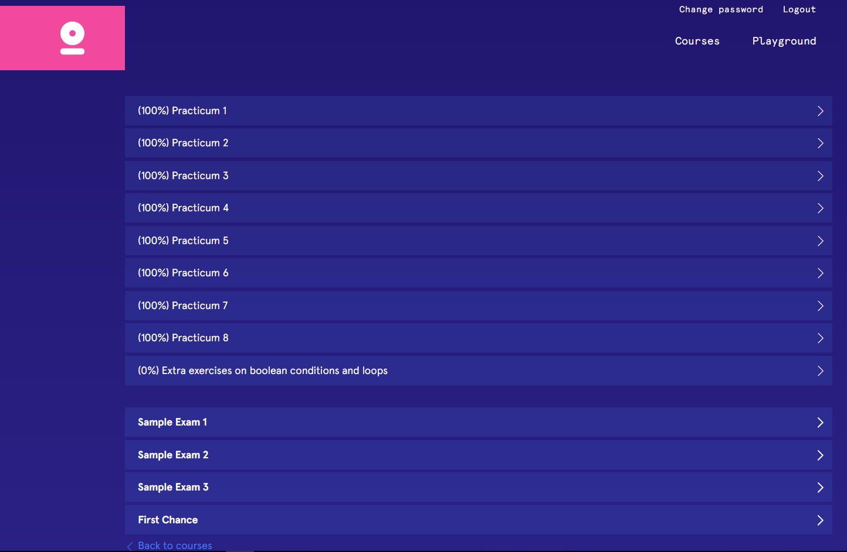

For each practicum you see also the percentage of completion.

# Types of exercises

When opening a practicum/exam, you will see a list of exercises. The exercises are divided in three categories:

* **Multiple choice questions** (MCQ): these are questions with some (usually four) possible answers, of which only one is correct.
* **Forward assignment** (FA): these are exercises where you get a working program and you are asked to complete some of the values in the state after some specific instructions of the program are executed.
* **Backward assignment** (BA): these are exercises where you get an incomplete program and the complete trace of memory states originated by the (unknown) complete program. You are asked to fill in the missing program parts that match the execution of the unknown program as described by the memory states.

## Multiple choice questions

To select one answer, click on the white square next to such answer. If the answer is wrong, it will take one minute before you can try another one (note: this does not apply to the exam).

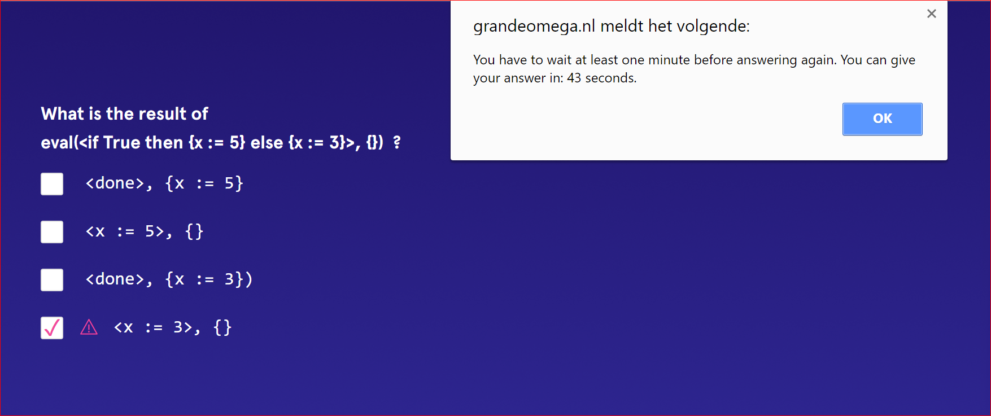

If the answer selected is wrong, then a “<!>” symbol will appear next to the wrong selected answer:

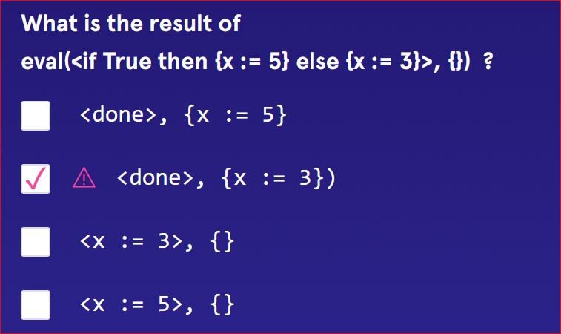

## Forward assignment

You start the assignment with an empty memory and the program on the screen. When you click on **Next**, the program states will move forward to the first one that you are required to complete. The parts to complete are visible as white input boxes. To see which row of the program has generated a specific memory state, click on the pink dot on top of such state (in the following picture you can see a 5 within a pink dot).

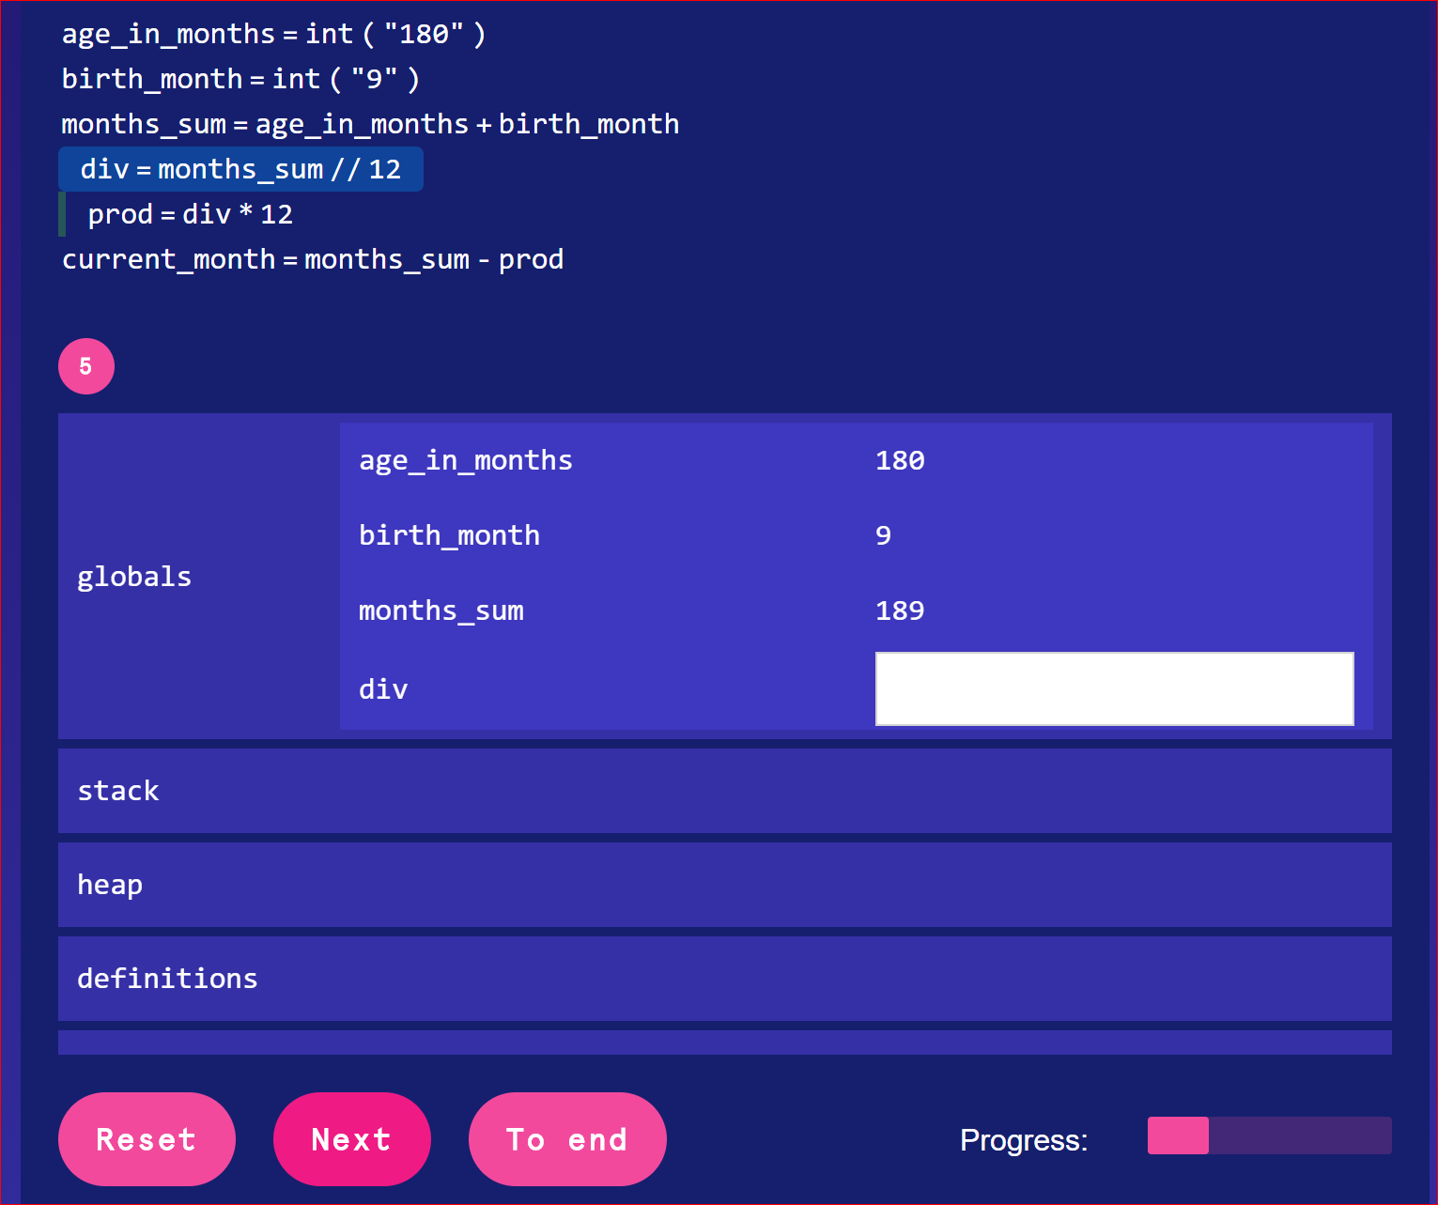

Only after filling in all the white input boxes, you can press **Next**.

If all values inserted are correct, then the progress bar will proceed, and the following values to be completed will be shown on the screen. When the progress bar is completely filled in, then the exercise is finished.

If one of the values of the state you inserted is not the one expected by the system, a “<!>” symbol will appear close to the wrong value:

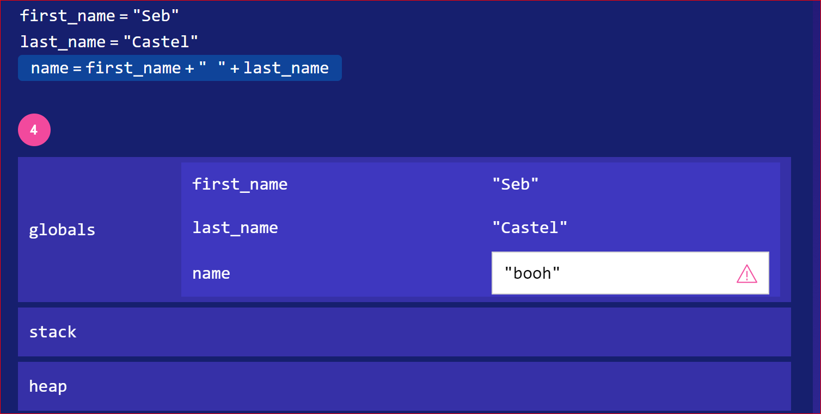

## Backward assignment

In a backward assignment you have to look at both the partially written program and the complete state trace to identify the missing code parts. You can fill in each missing code block by clicking on the white input box and writing the code. When you insert code in an input box, it is very important to separate the constructs by pressing *enter* after each one. Pressing enter informs the environment that you are done inserting a construct and that you are ready to enter the following construct (in the same way). To close a box, you need to press enter in an empty box. To delete a previously inserted construct or to go back to the previous box press *backspace*.

Example: if you want to insert the expression **i + 1**, then you need to write **i** followed by *enter* followed by **+** followed by *enter* followed by **1** followed by*enter* followed by*enter* (this last one is to close the input box).

To reopen an already closed input box, you need to click on the pink pencil next to it.

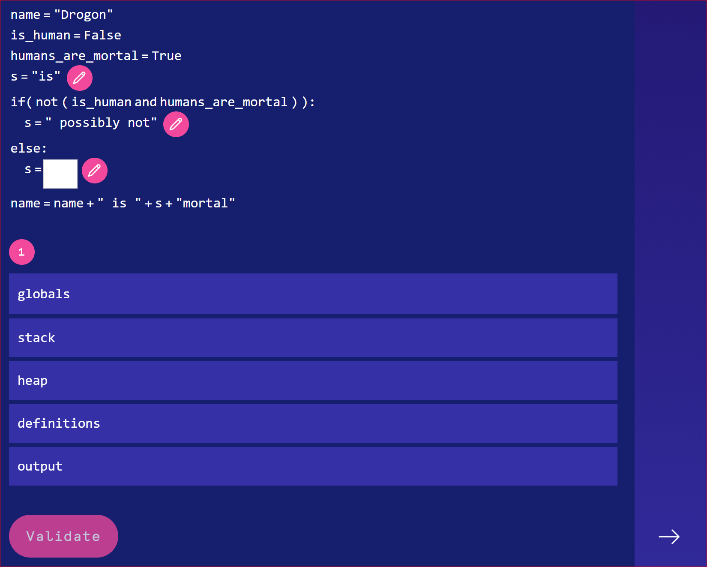

To complete (and thereby verify) the exercise you must press the *Validate* button. Note that you cannot press it before completing all boxes.

After clicking on *Validate*, if the program completed produces a state/memory that does not correspond to the expected one generated by the original (hidden) program, the screen shakes and a “<!>” symbol will appear next to each memeory value that does not correspond to the expected one:

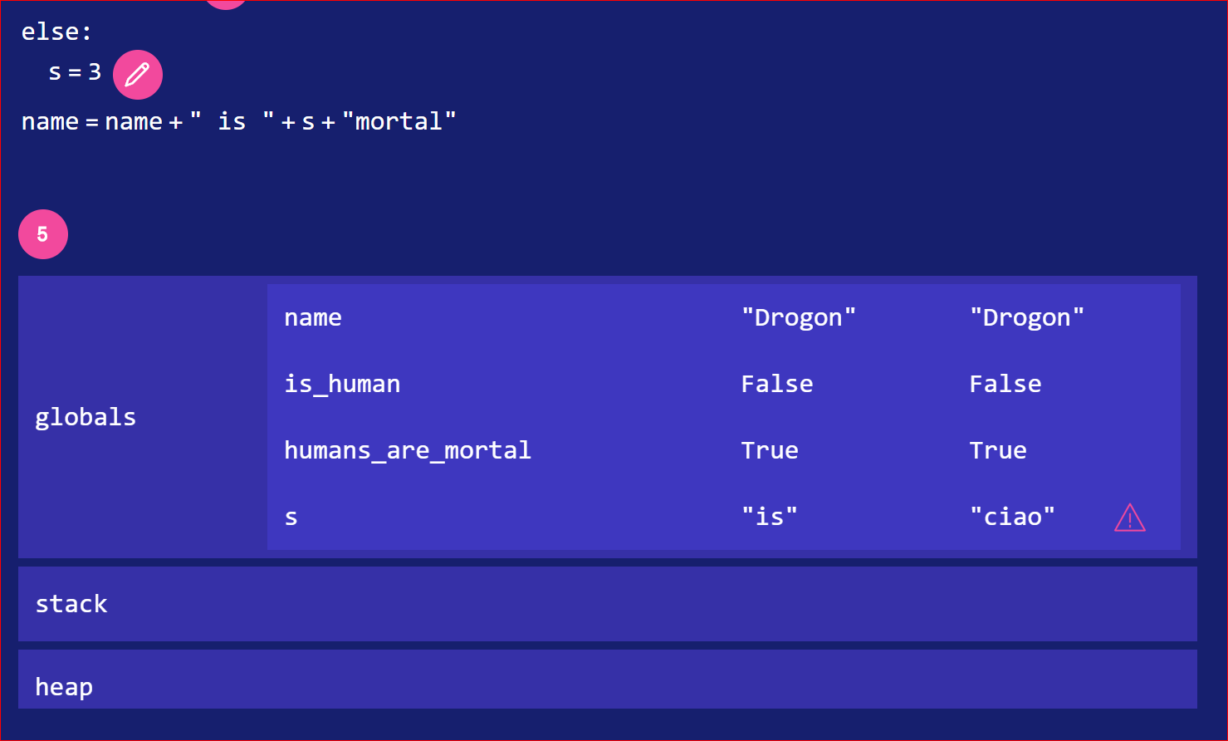

If the program contains no errors, no error messages are shown.

# Dashboard

Every interaction with the practicums is saved and you will be able to see your progress in the graph produced in the homepage of every course (below the list of didactical activities):

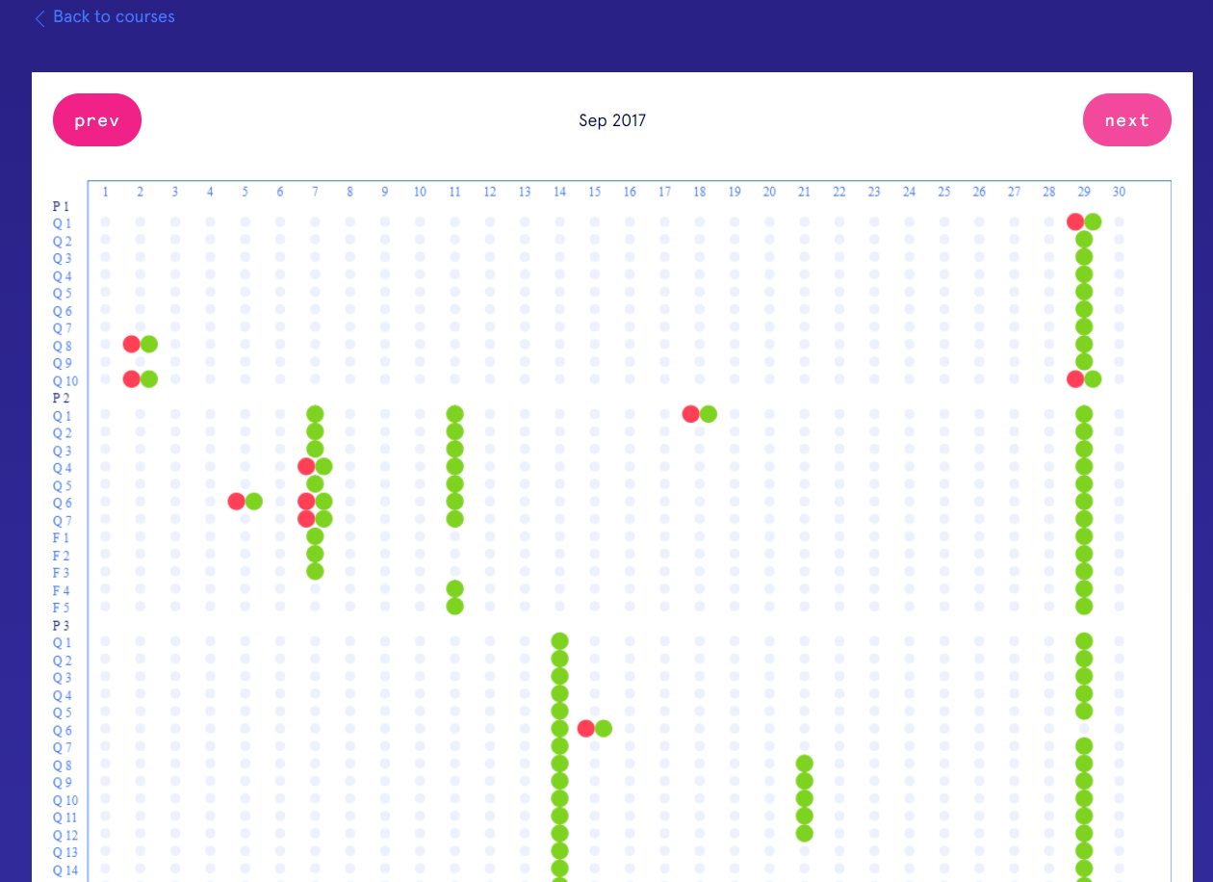

A red dot means you made a mistake, a green one means the exercise is correct, a yellow one means you attempted the exercise but not finished it, a red followed by green means you made some mistakes but in the end the exercise was completed correctly, a red followed by yellow means you made both mistakes and partial good answers but the exercise wasn’t fully completed.

# Exam

During the exam you will be asked to do a set of exercises similar to those seen in the practicum: MCQ, FA and BA.

When you click on the exam, you go to a screen waiting for confirmation. The teacher in the room will check your ID and confirm you so that you can access the exam.

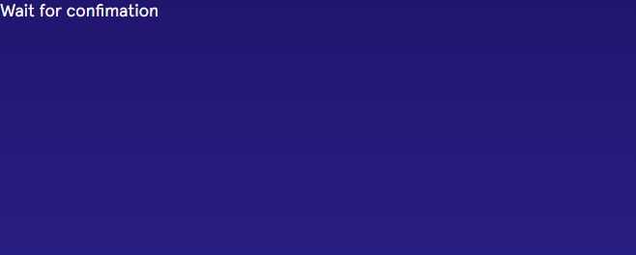

On the right part of the screen you will see the list of questions and clicking on each one you will be able to fill in the answers:

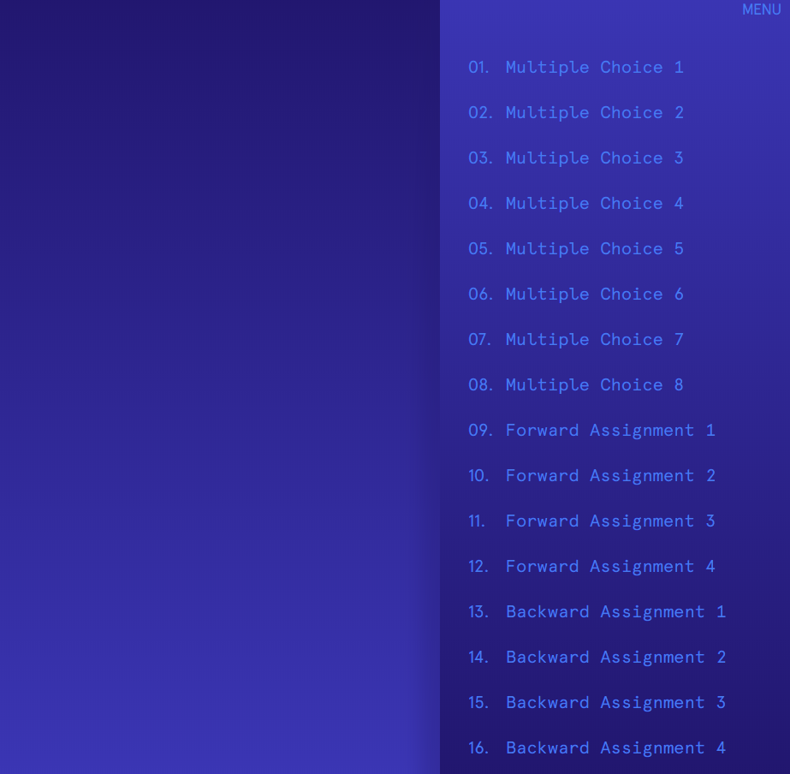

Some important notes on the exam session:

* Remember to use Google Chrome. Make sure that it is already installed on your laptop before starting the exam.



* During the exam you cannot open other pages or applications or change in any way the focus of the screen. If you do, a warning message appears and if the focus doesn’t come back within a short interval (written on the screen) you will be kicked out of the exam.



* In the top left of the screen you will see the **Timer** that shows the time remaining to the end of the exam. When the time is elapsed, your answers are automatically submitted to the system and you will be logged out.

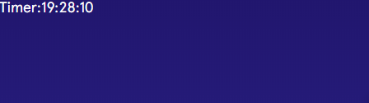

* The multiple choice questions do not, of course, give the feedback (<!>) and you can change a given answer whenever you want without waiting the usual minute.
* Remember that in the backward assignment you need to press ***Validate*** when you finish it. It is fundamental not only to give you feedback but also because your result for that exercise is stored in the system *only after* pressing this button.
* If you want to go back to a FA or BA to change your answers, you can. Just click on the exercise button and then wait for your previous answers to appear on the screen (in case you are doing a BA) or press next to see the previous answers (in case you are doing a FA).
* When you finish the exam and you want to deliver it, click on the **Submit and exit** button at the bottom right of the screen (at the end of the exercise list). A confirmation pop-up appears on screen and you must click OK to confirm.

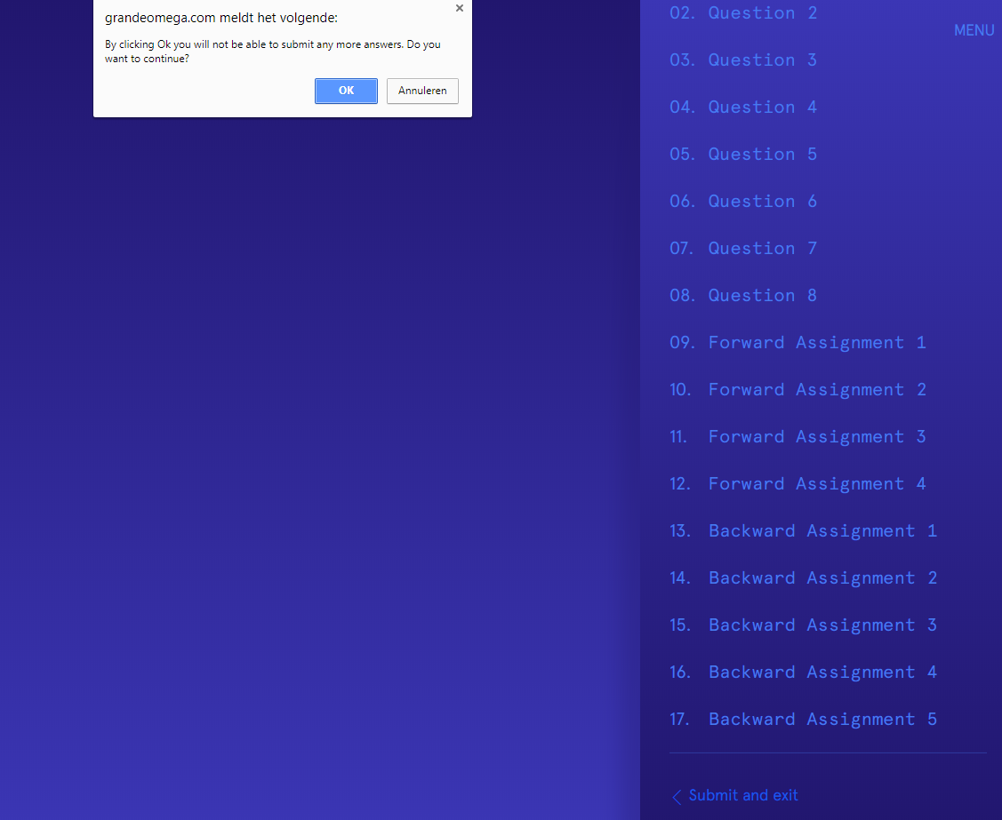

After doing this, you *cannot go back* to the exam again. A screen will appear, showing for each exercise the result (correct or wrong). The grade is not shown on the screen.

